11th December 2019

**WTA Lauds 2019 Dubai Duty Free Tennis Championships Women’s Event with Premier 5 Tournament of the Year Award**

**Summary:** At the annual Women’s Tennis Association (WTA) Year-End Tournament Awards, the Dubai Duty Free Tennis Championships was awarded with the ‘Premier 5 Tournament of the Year’ as voted by the players.

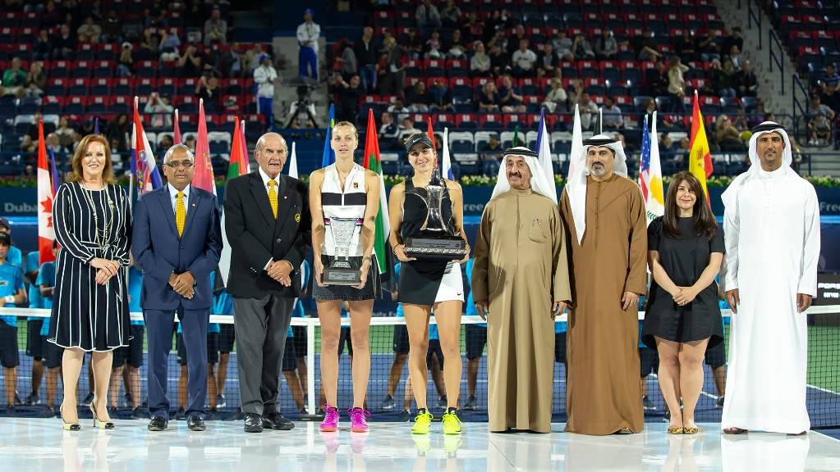

The closing ceremony of the Dubai Duty Free Tennis Championships 2019, which was named  WTA Premier 5 of the Year Award.Pictured from (L-R) Sinead El Sibai, Senior Vice-President Marketing – Dubai Duty Free, Ramesh Cidambi, Chief Operating Officer - Dubai Duty Free, Colm McLoughlin, Executive Vice Chairman and CEO - Dubai Duty Free, Petra Kvitova, Belinda Bencic, His Highness Sheikh Hasher Bin Maktoum Al Maktoum, President of Tennis Emirates, Salah Tahlak, Tournament Director, Kathryn Reagan, Vice President, Partnerships - WTA, Naser Yousef, Secretary General - Tennis Emirates.

At the annual Women’s Tennis Association (WTA) Year-End Tournament Awards, the Dubai Duty Free Tennis Championships was awarded with the ‘Premier 5 Tournament of the Year’ as voted by the players.

The WTA Year-End Tournament Awards recognise WTA tennis tournaments in four categories: Premier Mandatory, Premier 5, Premier and the International category. The players vote on these awards, with the winners receiving recognition due to the excellence of their staff and organisation, the passion of their fans, and wider dedication to the sport and athletes.

The Dubai Duty Free Tennis Championships, which is owned and organised by Dubai Duty Free, began with a Men’s ATP week in 1993, with the Ladies WTA week joining the tournament in 2001, becoming a two-week back-to-back event. The inaugural WTA event in 2001 was voted and awarded as the “Best Tournament of the Year” while in 2015, the tournament was awarded with its first “Premier 5 Tournament of the Year Award”.

Announcing the Dubai award, Steve Simon, WTA CEO & Chairman said, “This award is an incredible achievement as it recognises the tremendous amount of dedication, investment, and welcoming spirit that Dubai Duty Free Tennis Championships provide to ensure the special experience that our WTA athletes enjoy in Dubai. We are very proud to honor you as a standout tournament that has given women’s tennis such a special stage on which to compete.”

Commenting on the WTA award Colm McLoughlin, Executive Vice Chairman & CEO, Dubai Duty Free said: “We are thrilled that the WTA players have voted the Dubai Duty Free Tennis Championships as the WTA Premier 5 Tournament of the Year. Receiving this recognition in the Premier 5 category, which includes tournaments in Rome, Cincinnati, Toronto/Montreal, and Wuhan, is a great achievement and my thanks to all involved in making this tournament a great success.”

“We were one of the first tournaments at our level to introduce equal prize money for the WTA players and we have remained committed to such equality. Our thanks to the WTA team and the players for recognizing the efforts made by Dubai Duty Free in organizing this world-class tournament. We look forward to welcoming the WTA Tour once more next February.”

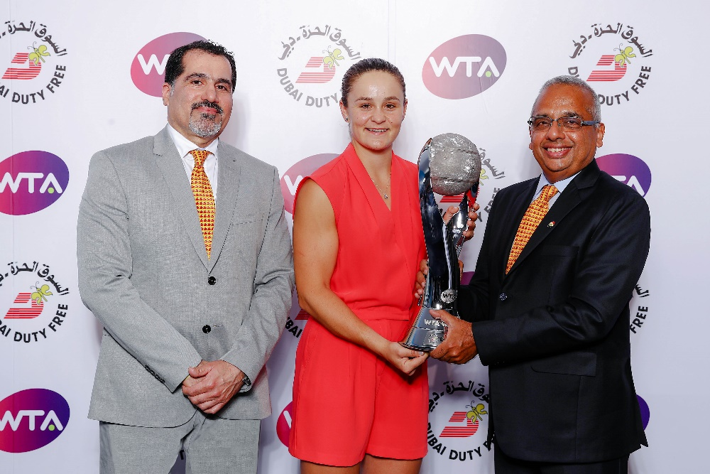

Dubai Duty Free Chief Operating Officer Ramesh Cidambi and Salah Tahlak, Executive Vice President-Corporate Services presented the WTA Year-End Singles No.1 to Ashleigh Barty in Shenzhen, China in October 2019.

Salah Tahlak, Tournament Director, Dubai Duty Free Tennis Championships said: “Thanks to the WTA players for giving the Dubai Duty Free Tennis Championships their vote as Premier 5 Tournament of the Year. As you can imagine, there is a lot of hard work that goes on behind the scenes to make this event a success and my thanks to everyone involved. Thanks in particular to Colm McLoughlin, our EVC & CEO for his ongoing support and to our COO Ramesh Cidambi for working with us to continually improve the tournament standards year to year and to Sinead El Sibai, our Senior Vice President Marketing, who works tirelessly for the players, officials, sponsors and tennis fans.”

“Thanks also to our Tournament Patron, H.H. Sheikh Mohammed bin Rashid Al Maktoum, Vice President and Prime Minister of the UAE and Ruler of Dubai, for his ongoing support.”

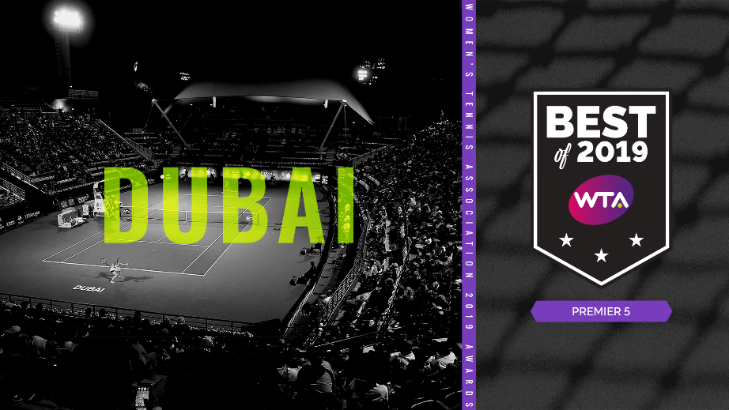

Dubai Duty Free Tennis Championships Women’s Event was awarded with Premier 5 Tournament of the Year Award as voted by the players

February 2020 marks the 20th anniversary of the WTA week in the Dubai Duty Free Tennis Championships taking place from 17th – 29th February at the Dubai Duty Free Tennis Stadium.

* Ends -

For further information, please contact Bernard Aquino, Marketing Department,

Dubai Duty Free or call Tel: +9714-6019232 or email: [bernard.aquino@ddf.ae](mailto:bernard.aquino@ddf.ae)